Income Factors-Mean Adjustment and Why Income Is Not Clamped
The model intentionally does not clamp continuous income during factors-mean adjustment. This is by design to preserve the income scale used by factors-mean calibration and to avoid artificially compressing income distribution, which would distort income strata assignment and final categories.

Input From Data Files
income_model.csv (continuous-income regression) includes:
- Intercept = 433.6063187
- min = 23
- max = 2379
- stddev = 291.0482219
Finch.FactorsMean.Female.csv and Finch.FactorsMean.Male.csv include an Income expected series (by age), e.g.:
- Age 0 Income expected ~= 621.3036
- Age 18 Income expected ~= 643.7213
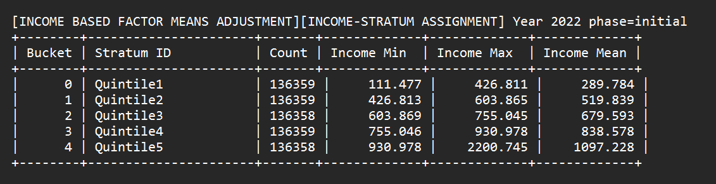
- Max income in factors means =769.09
[INCOME] After adjustment, income stats: min=29.6511 max=1716.06 mean=685.081 n=6817
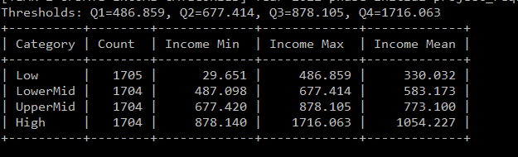

Why Not Clamping Income During Factors-Mean Adjustment
During adjustment, delta is computed as (expected - simulated_mean) and then applied per person. For income, clamping at this stage can truncate adjusted values and collapse distribution tails. That causes poor stratum separation and weakens the intended calibration to income-based expected means.
In contrast:
- Regular risk factors and PhysicalActivity can be clamped to configured ranges after delta application.
- Income uses a dedicated continuous-income pathway and is re-bucketed later into final categories (3 or 4) by rank.
- Keeping income unclamped here preserves meaningful rank ordering for strata and final category assignment.

Current Behavior
- Do not clamp income in the income factors-mean adjustment pass.
- Allow rank-based stratum assignment from adjusted continuous income.
- Apply final project_requirements income categories after adjustment pipeline.
- Keep normal clamping for non-income factors (and PhysicalActivity where configured).

